EXCRETION

Introduction
Excretion means the separation and elimination of waste materials from the body through a special structure called the excretory organ. Humans must get rid of two types of wastes. Wastes from the digestive system (feces) and wastes from metabolic activities (e.g. sweat and urine). Removing digestive wastes is called egestion. Removing metabolic wastes is called excretion.

Excretory organs
There are four excretory organs in human: The skin, the lungs, the liver, and the kidney (Urinary system).

The skin
The skin is formed of two layers; the thin epidermis at the top, and the thicker dermis below. The inner layer of skin (dermis) contains the oil glands, hair follicles, fatty layers, nerves, and sweat glands. The sweat gland leads to the sweat duct (tube) which opens on the skin surface through a pore (Fig. 1). Sweat is a mixture of three metabolic wastes: water, salts, and urea. So as you sweat, your body accomplishes two things: 1) sweating has a cooling effect on the body, and 2) metabolic wastes are excreted.

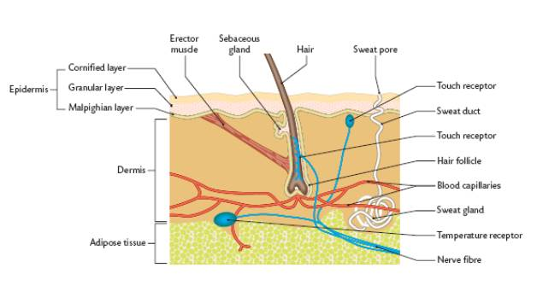

Sweat formation
Sweat gland is a tubular structure tangled with the blood capillaries. This close association of tubes allows wastes (namely water, salts, and urea) to diffuse from the blood into the sweat gland. When body temperature rises, the fluid (sweat) is released from the gland, travels through the duct, and reaches the skin surface through openings called pores.

The Lungs
Cellular respiration occurs in every living cell in your body. It is the reaction that provides energy (in the form of ATP molecules) for cellular activities. If respiration stops, the cell no longer has the energy for cellular activities, and the cell dies. As respiration occurs carbon dioxide is produced as a waste product. As the carbon dioxide accumulates in body cells, it eventually diffuses out of the cells and into the bloodstream, which eventually circulates to the lungs. In the alveoli of the lungs, carbon dioxide diffuses from the blood, into the lung tissue, and then leaves the body every time we exhale. Some water vapor also exits the
body during exhalation (Fig. 2).
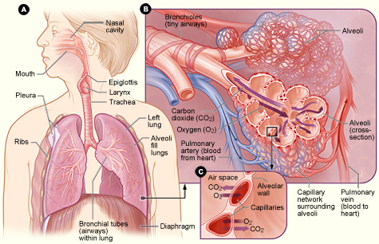

The liver
The liver is a large, important organ in our bodies. Its numerous functions make it "part" of the circulatory, digestive, and excretory systems. Liver as an excretory organ acts to break down some proteins and other nitrogenous compounds by a process called deamination. As a result of these reactions, a nitrogenous waste called urea is formed. Liver as well as helps in excreting toxic substances, drugs, and their derivatives; and bile pigments and cholesterol (Fig. 3).
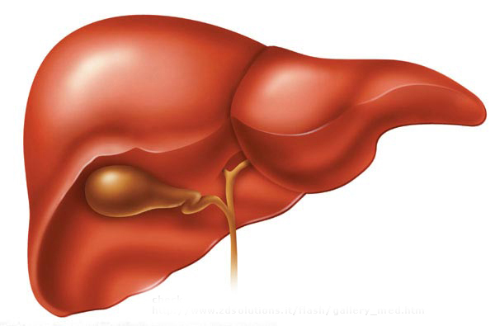
The urinary system
The urinary system consists of two kidneys, two ureters, urinary bladder, urethra, and excretory opening (Fig. 4).
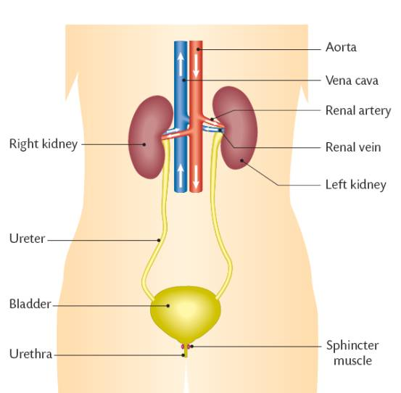

Two kidneys
They are dark, red, bean-shaped and lie in the upper part of the abdominal cavity against the dorsal body wall. They are embedded in a protective layer of fat and connective tissue. The right kidney is slightly on a lower level than the left. Each Kidney is about 4½ inches long, 2½ inches broad, and over one inch thick. The weight of each kidney in an adult human is about 150 g, so they represent about 0.5% of the total weight of the body. They are divided into three regions- the renal cortex which is the outer layer, the renal medulla which is the inner layer and the renal pelvis which is responsible for carrying the urine from the kidney to the ureter (Fig. 5).
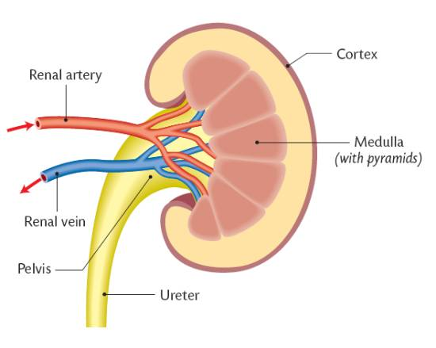
Each kidney in the human contains about 1 million nephrons, each capable of forming urine. The kidney cannot regenerate new nephrons. Therefore, with renal injury, disease, or normal aging, there is a gradual decrease in nephron number. Each nephron contains (1) Malpighian body, which is made up of a glomerulus and a Bowmanʼs capsule. The glomerulus is a mass of convoluted blood capillaries supplied by a wide afferent arteriole and drained by a narrow efferent arteriole. (2) The uriniferous tubule, which is divided into three parts; a proximal convoluted tubule, Henelʼs loop, and a distal convoluted tubule which opens into a collecting tubule. The collecting tubules of all excretory units are joined together forming a duct of Bellini, which runs up to the pelvis ( Fig. 6).

Two ureters
They are two slender muscular tubes which
take their origin at the hilum of each kidney (from the renal pelvis) and run down to join the urinary bladder.

The urinary bladder
The bladder has an elastic wall and placed in the lower part of the
abdominal cavity. It supplied with sphincter muscles at its connection
with both the ureters and urethra.

The Urethra
It is a muscular tube which carried the urine
from the bladder to the outside.
Physiological functions of kidneys
- Excretion of metabolic waste products, foreign chemicals, Drugs, and Hormone Metabolites.
The kidneys are the primary means for eliminating waste products of metabolism that are no longer needed by the body. These products include urea (from the metabolism of amino acids), creatinine (from muscle creatine), uric acid (from nucleic acids), end products of hemoglobin breakdown (such as bilirubin), and metabolites of various hormones. These waste products must be eliminated from the body as rapidly as they are produced. The kidneys also eliminate most toxins and other foreign substances that are either produced by the body or ingested, such as pesticides, drugs, and food additives.

- Regulation of water and electrolyte balances.
For maintenance of homeostasis, excretion of water and electrolytes must precisely match intake. If intake exceeds excretion, the amount of that substance in the body will increase. If the intake is
less than excretion, the amount of that substance in the body will decrease. Intake of water and many electrolytes is governed mainly by a person’s eating and drinking habits, requiring the kidneys to adjust their excretion rates to match the intake of various substances.

- Regulation of arterial pressure.
The kidneys play a dominant role in long-term regulation
of arterial pressure by excreting variable amounts of sodium and water. The kidneys also contribute to short-term arterial pressure regulation by
secreting vasoactive factors or substances, such as renin, that lead to the formation of vasoactive products (e.g., angiotensin II).

- Regulation of acid-base balance.
The kidneys contribute to acid-base regulation, along with the lungs and body fluid buffers, by excreting acids and by regulating the
body fluid buffer stores. The kidneys are the only means of eliminating from the body certain types of acids, such as sulfuric acid and phosphoric acid, generated by the metabolism of proteins.
- Gluconeogenesis.
The kidneys synthesize glucose from amino acids and other precursors during prolonged fasting, a process referred to as gluconeogenesis.

- Production of erythropoietin, which stimulates red blood cell generation in the bone marrow.

- Conversion of vitamin D into an active form for the regulation of calcium balance.

Urine formation
Nephrons are responsible for the formation of urine that occurs in three steps (Fig. 7): (I) Filtration of water and dissolved substances from the blood into Bowman’s capsule and this occurs through the glomerulus. (II) Reabsorption of water and solutes through the uriniferous tubules. (III) Secretion into the lumen of the tubule of some substances formed by the tubule cells or which are circulating in peritubular venous capillaries surrounding the distal tubule.
Urinary excretion rate = Filtration rate - Reabsorption rate + Secretion rate

(I) Glomerular filtration of water and solutes from the blood
Each nephron has its own blood supply from the renal artery. A network of capillaries known as the glomerulus is located at the beginning of each nephron in the kidney. It serves as the first stage in making urine by separating the liquid part of the blood, the plasma. The blood plasma is filtered through the capillaries of the glomerulus and the filtered liquid from the blood, known as the filtrate, collects into the Bowman’s capsule. Like most capillaries, the glomerular capillaries are relatively impermeable to proteins, so that the filtered fluid (called the glomerular filtrate) is essentially protein-free and devoid of cellular elements, including red blood cells. The concentrations of other constituents of the glomerular filtrate, including most salts and organic molecules, are similar to the concentrations in the plasma. Exceptions to this generalization include a few low-molecular-weight substances, such as calcium and fatty acids, that are not freely filtered because they are partially bound to the plasma proteins. Almost one half of the plasma calcium and most of the plasma fatty acids are bound to proteins, and these bound portions are not filtered through the glomerular capillaries.

(II) Reabsorption of water and solutes through the uriniferous tubules
The Bowman’s capsule then empties the filtrate, into the proximal tubule of the nephron. This region of the kidney is responsible for the reabsorption of glucose, amino acids, various ions, and water. The filtrate then passes through the loop of Henle where it loses water and ions such as sodium, chloride, calcium, and potassium. What is not reabsorbed within the loop of Henle eventually passes into the distal convoluted tubule. The distal convoluted tubule selectively reabsorbs or secretes based on several factors, one being hormonal control.

(III) Tubular secretion
Some substances are removed from the blood through the peritubular capillary network into the distal convoluted tubule or collecting duct. These substances are hydrogen ions, creatinine, and drugs.

Regulation of urine concentration
In the distal convoluted tubule (DCT) and collecting duct CD, the osmolarity and ionic content of the urine can be altered. This is regulated by three hormones: antidiuretic, aldosterone, and Renin.

Antidiuretic hormone (ADH)
ADH is secreted by the posterior pituitary in response to either increased plasma osmolarity (is a measure of the different solutes in plasma) or a large decrease in plasma volume. It acts on the CD epithelial cells in the kidney medulla to increase their permeability to water (water moves from urine to the blood) leading to an increase in the concentration of urine and blood pressure.

Aldosterone
The adrenal gland secretes aldosterone in response to either elevated plasma K⁺ or angiotensin II. It regulates the movement of water and Na⁺ across the CD epithelial cells.Na+ is reabsorbed from the filtrate and K+ is secreted into the renal tubule from the blood. Because water follows Na+, aldosterone concentrates urine, increases the volume of the blood and blood pressure. Note that aldosterone is not secreted when plasma Na+ concentration is high.

Renin-angiotensin II-aldosterone system (RAAS)
The renin-angiotensin system regulates blood pressure and fluid balance in the body. When blood volume or sodium levels in the body are low, or blood potassium is high, cells in the kidney release renin. Renin converts angiotensinogen, which is produced in the liver, to the hormone angiotensin I. An enzyme known as ACE or angiotensin-converting enzyme found in the lungs metabolizes angiotensin I into angiotensin II. Angiotensin II causes blood vessels to constrict and blood pressure to increase. Angiotensin II stimulates the release of the hormone aldosterone in the adrenal glands, which causes the renal tubules to retain sodium and water and excrete potassium. Together, angiotensin II and aldosterone work to raise blood volume, blood pressure and sodium levels in the blood to restore the balance of sodium, potassium, and fluids. If the renin-angiotensin system becomes overactive, consistently high blood pressure results (Fig. 8).

